ABC TELECOM

We survive because of our customers
ABC is a publicly listed company founded in March 2007 having more than 40 million customers around the world. True to our origins, we have always committed to deliver useful and inspiring innovation. Our commitment to the community in which we operate extends beyond the products and services we offer. We offer different types of services to the customer like voice, data, text, video etc. To achieve this, company is maintaining a database of customer and service information. Following diagram shows the end to end structure along with the relationship among the entities.
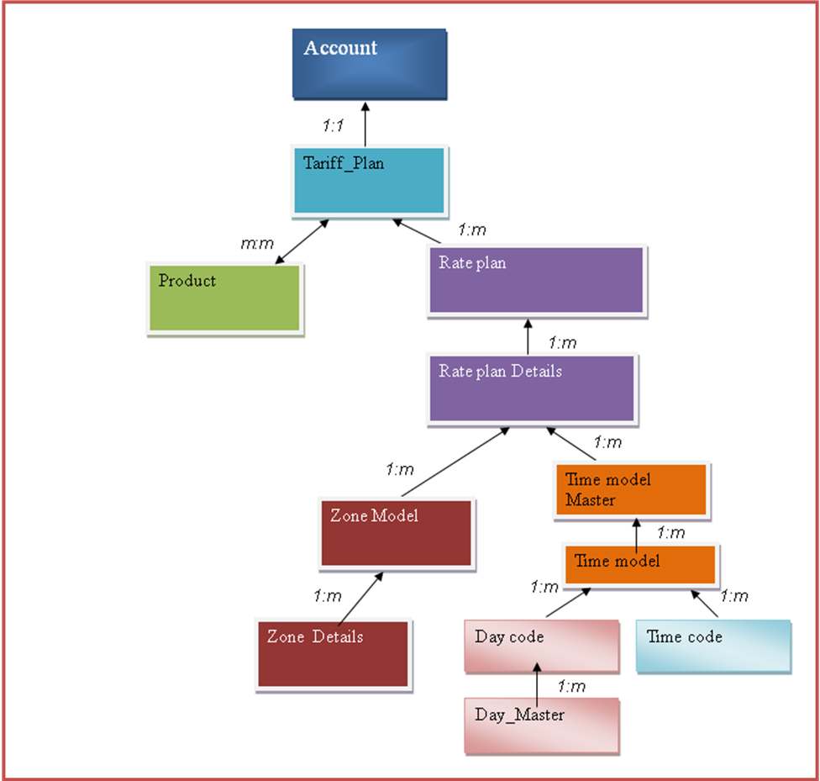
Note: We will be following the bottom-up approach to create this structure
Day_Master /Day Code: Day master table contains information about days. The day code entity describes the definition of the days like weekday, weekend and which range of days are included in it.
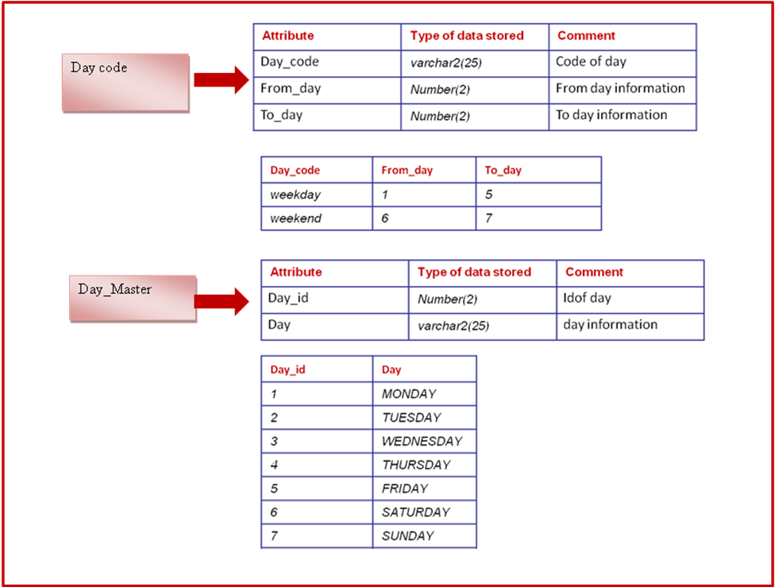
Time Code: The time code entity describes the definition of the times like peak/off-peak etc. Time_from and Time_to denotes a 24 Hr clock format.
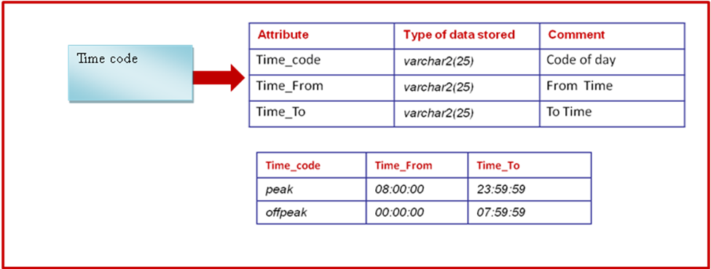

Time Model Master/Time Model: The time model master contains information about time models. The time model defines the association between the day code and time code.
For example: Weekday Peak, Weekday off-peak, Weekend peak etc.
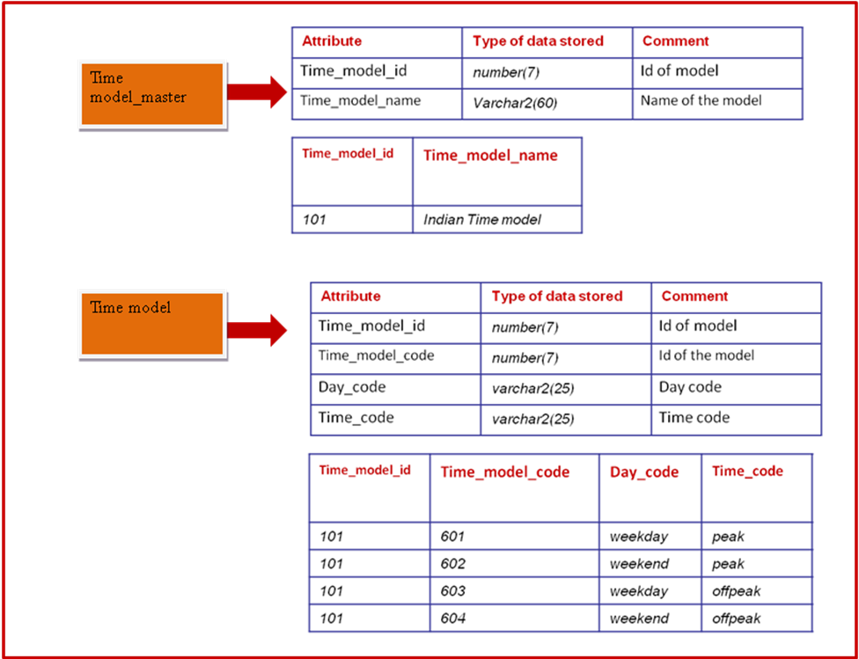
Zone Model: Zone model defines the zones like local/STD/ISD. Firstly you need to define the zones and then for every zone you need to store the prefixes of source and destination numbers. First 4 digits of phone number is called as prefix. Source prefix and destination prefix decides the zone of the call.
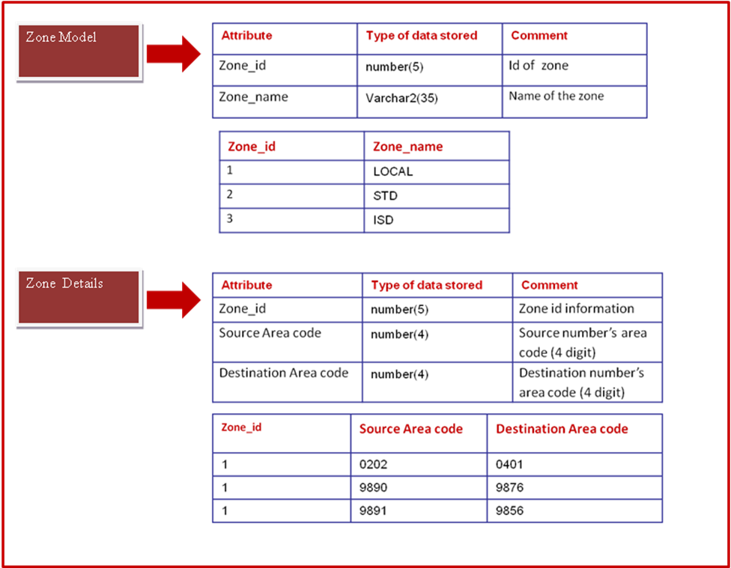

Rate Plan: Rate plan is created to represent the usage charges. Rate plan defines the name of the rate plan and the effective dates to sale the rate plans.
Rate Plan Details: Rate plan details stores the actual usage charges based on the zone and time model. For example: Local Week day peak Rs. 2/min etc.
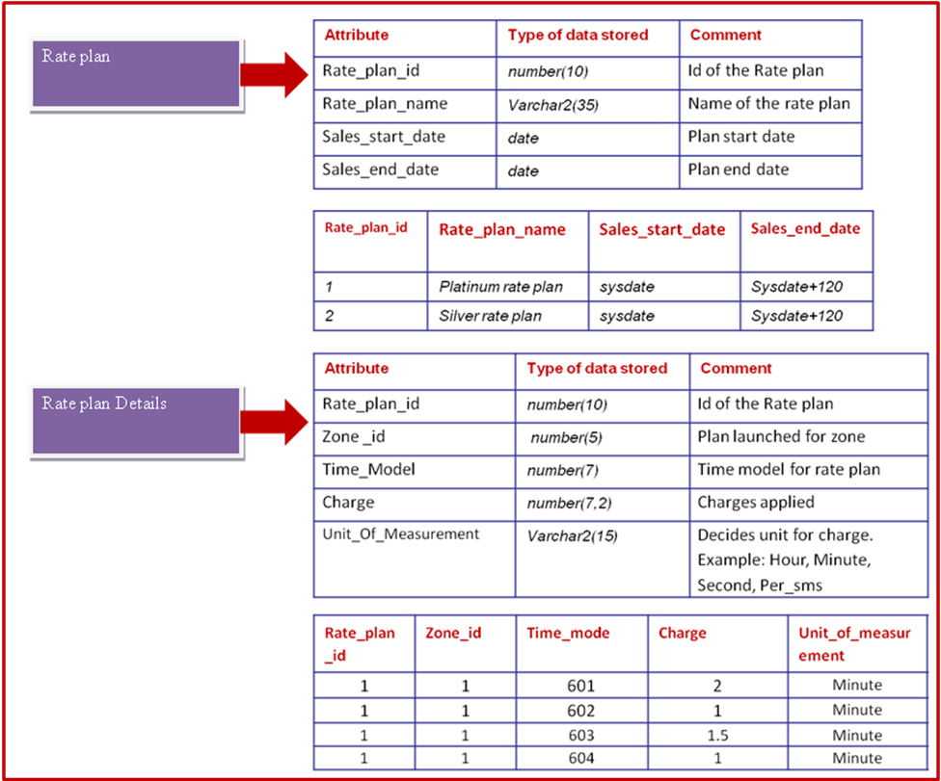

Products: The products are created to represent the service purchased by the customer.
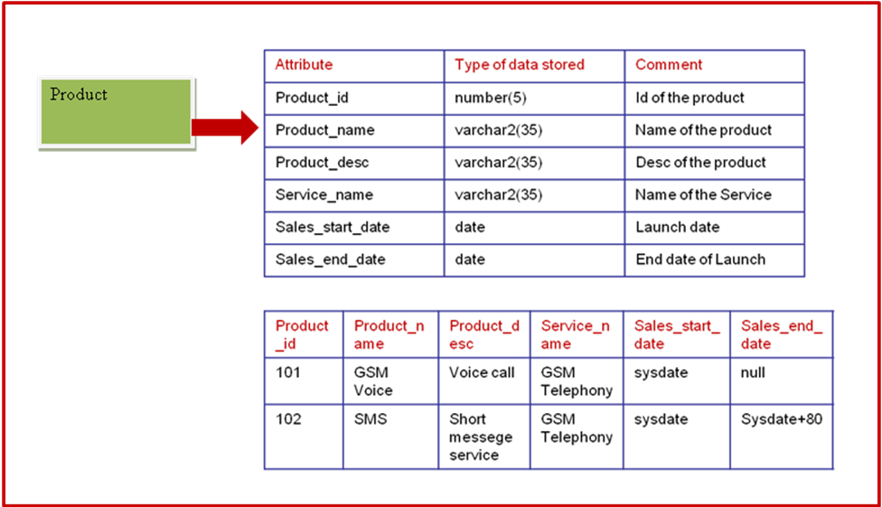

Day1 Session Assignments(Faculty+Participants)
Concept: SQL Basics, DDL commands- Create table without constraints and with constraints, Alter, truncate, and Drop.DML commands Insert, Update, and Delete. Transaction Control Commit, Rollback, and Savepoint.
Objectives: At the end of the assignments, participants will be able to implement basic DDL / DML/ Transaction Control statements.

- Tariff plan is the bundle which contains various products (Services) and their rate plan (usage charges). It also contains the onetime charges like purchase fees and the recurring charges like monthly rentals.
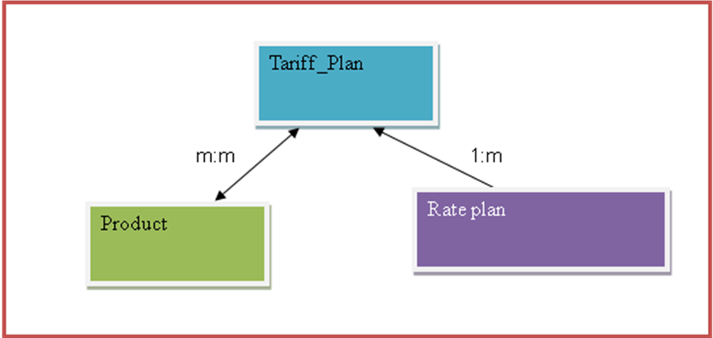
Tariff plans are created in the database before it is offered to the customer. It contains the information as follows
Tariff_plan:
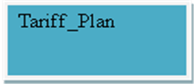
Attribute | Type of data stored | Comment
Tariff_id | number(5) | Id of the tariff. This contains the unique and not null value
Tariff_name | Varchar2(35) | Name of the tariff.
Tariff_desc | Varchar2(35) | Description of the tariff

Tariff_product_details:
Attribute | Type of data stored | Comment
Tariff_id | number(5) | Id of the tariff
Initiation_charge | number(7,2) | Initial charge
Recurring_charge | number(7,2) | Recurring charge
Product_id | number(5) | Product under the plan referred from the product table
Rate_plan_id | number(10) | Rate for the plan referred from the rate plan table
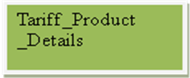

- View the structure of the tables created.
- The customer approaches the service provider to get the communication services and for that customer, the account is created in the system. The account is a legal entity which tracks the balance of the customer. An account then purchases a tariff plan.
An account stores the information as follows with some rules:
- Account_No: Need to be unique and NOT NULL
- Account_name should not be left blank
- MSISDN No should not exceed more than 10
- The difference between last bill date and next bill date should be min of 30 days
- By default Currency of the Account can be INR.

Attribute | Type of data stored | Comment
Account_no | number(10) | Account no of the customer
Account_name | Varchar2(35) | Name of the account
Currency | Char(6) | Currency of the account
Billing_address | Varchar2(35) | Address at which bill would be received
Active_date | Date | Date of activation
Next_bill_dtm | Date | Next bill date
Last_bill_dtm | Date | Last bill date
MSISDN_no | number(10) | Mobile Number


- Modify the size of the Billing_address field to 75
- Add a new column SIM_No number(25) in account table
- Change the Name of The ACCOUNT Table to ACCOUNT_DETAILS

- Rename column Billing_address of account table to invoice_post_address

- Add a new field tariff_id number(5) in account table which will be referred from the tariff_plan table.
- Now since we have successfully created few tables we need some data inside it as follows. Add rows in the Product, ACCOUNT_DETAILS, TARIFF_PLAN AND TARIFF_PRODUCT each as follows
Product_id | Product_name | Product_desc | Service_name | Sales_start_date | Sales_end_date
103 | call waiting | call waiting | GSM Telephony | sysdate | sysdate+90
104 | call forwarding | call forwarding | GSM Telephony | sysdate | null
105 | missed call alert | missed call alert | GSM Telephony | sysdate | sysdate+90

Tariff_id | Tariff_name | tariff_desc
201 | Platinum 199 plan | Platinum 199 plan
202 | Silver 299 plan | Silver 299 plan

Tariff_id | Initiation_charge | Recurring_charge | Product_id | Rate_plan_id
201 | 50 | 199 | 101 | 1
201 | 10 | null | 102 | 1
202 | 30 | 299 | 101 | 2
202 | 10 | null | 102 | 2
202 | null | 25 | 103 | null

9. a) Insert recurring charge(monthly fee) Rs.25 for the product call waiting(product_id 103) In platinum 199 plan(tariff_id 201) using a selected column list

9. b) Insert initiation charge(purchase fee) Rs.10 and rate plan id 3 for the product SMS(product_id 102) In silver 299 plan(tariff_id 202) by accepting data from the user in the selected column list

Account_no | Account_name | Currency | Billing_address | Active_date | Next_bill_dtm | Last_bill_dtm | MSISDN_no | SIM_no | Tariff_id
501 | Deepali patki | INR | Sinhgad rd pune | sysdate-30 | sysdate+30 | sysdate | 9890012345 | 499132136274347634 | 201
502 | Vijay | INR | Kothrud | sysdate-30 | sysdate+30 | sysdate | 9890098764 | 49913213627489076 | 201
503 | Ashwini | INR | Nagar rd pune | sysdate-30 | sysdate+30 | sysdate | 9890045645 | 499132136274348000 | 201

- Change the name account_details to account

- Add a 4th row only in ACCOUNT Table with details as follows :
ACCOUNT_NO – 1080
ACCOUNT_NAME – PRASAD MEHTA
CURRENCY - INR
BILLING _ADDRESS – KARVE ROAD
ACTIVE_DATE- SYSDATE -30
NEXT_BILL_DATE – SYSDATE+15
LAST_BILL_DATE – SYSDATE +15
MSISDN_NO- 9874356711
SIM_NO -765237625787828271
TARIFF_ID - 205

Do you observe any errors … If Yes specify the reason and modify the same?

- Update the billing_address to ‘Viman Nagar Pune’

- Update the account_name from ‘Vijay’ to ‘Vijay Arjunwadkar’ where account_no=502

- Remove the account no 1080 from the account table

- All the changes made need to be treated as permanent.

Practice Assignments for the participants after the session
A service provider has decided to maintain a separate SIM and MSISDN inventory details.
Following are the details.
MSISDN_Master:
Attribute | Type of data stored | Comment
MSISDN_no | number(10) | MSISDN no present in the inventory. This contains the unique and not null value
MSISDN_Type | Varchar2(35) | Type of the MSISDN like Normal, Special etc
Status | Varchar2(35) | Status of the Mobile no like allocated,free,Quarentine etc.

SIM_Master:
Attribute | Type of data stored | Comment
SIM_no | number(25) | SIM no present in the inventory. This contains the unique and not null value
SIM_Type | Varchar2(35) | Type of the SIM like 64k,128k etc
Status | Varchar2(35) | Status of the SIM no like allocated,free,Quarentine etc.

- Insert the following data in the above table
MSISDN_no | MSISDN_Type | Status
9890012345 | Special | allocated
9890098764 | Normal | allocated

SIM_no | SIM_Type | Status
499132136274347634 | 64k | allocated
49913213627489076 | 128k | allocated

- Have you used this SIM_no and MSISDN_no in any other table. If yes name the table?
- Alter this table to modify SIM_no and MSISDN_no as foreign key into the table found. Did you get any errors? If Yes Why?
- Modify the same to remove the error.
- A service provider has now decided to maintain a details of the calls made by the customers.
Following are the details
Usage_Details:
Attribute | Type of data stored | Comment
Source_calling_number | Number(10) | MSISDN Number of source
Destination_called_number | Number(10) | MSISDN Number of destination
Start_Time_Stamp | Timestamp | Date and Time of call or SMS
End_Time_Stamp | Timestamp | Time of call. 24 Hr clock format time
Call_Duration | Number(5) | Duration of call in minutes. Calculated as End_Time_Stamp- Start_Time_Stamp.
No_of_SMS | Number(5) | This field will contain the value of number of SMS for SMS usage details.

Sample Data
Source_calling_number | Destination_called_number | Start_Time_stamp | End_Time_stamp | Call_duration | No_of_SMS
9890012345 | 9876456734 | ’06-FEB-12 08.00.00’ | ’06-FEB-12 08.10.00’ | 10 | null
9890098764 | 9876123678 | ’06-FEB-12 08.00.00’ | ’06-FEB-12 08.15.00’ | 15 | null
9890098764 | 9857589011 | ’06-FEB-12 08.00.00’ | ’06-FEB-12 08.17.00’ | 17 | null
9890098764 | 9857589013 | ’06-FEB-12 08.00.00’ | ’06-FEB-12 08.10.00’ | 10 | Null
9890012345 | 9857589013 | ’06-FEB-12 08.00.00’ | null | null | 1
9890098764 | 9857589011 | ’06-FEB-12 07.00.00’ | ’06-FEB-12 07.10.00’ | 10 | null

- Add 5 more rows in the above table
- Modify the account table and add account_type varchar2(35) column and restrict the values to ‘Residential’,’Business’
- Update account_type=’Residnetial’ for account_no 501 and 502
- Update account_type=’Business’ for account_no 503
- Modify the account table and add account_status varchar2(10) column and restrict the values to ‘Active’,’Suspend’,’Cancel’
- Update account_status to ‘Active’ for all existing records
- Add few rows in Account table

